UCS1601---Internet Programming

Assignment – 3

***Swetha Saseendran***

***CSE-C***

***185001183***

**Aim:**

* To install JDK, Tomcat server and deploy a servlet program.
* To write the servlet program to read username, email-id and transmit it to the server, where server displays a table for username and email.

**Code:**

web.xml File

<web-app>

    <servlet>

    <servlet-name>HelloForm</servlet-name>

    <servlet-class>HelloForm</servlet-class>

    </servlet>

    <servlet-mapping>

    <servlet-name>HelloForm</servlet-name>

    <url-pattern>/HelloForm</url-pattern>

    </servlet-mapping>

</web-app>

index.html File

<!DOCTYPE html>

<html lang="en">

<head>

    <meta charset="UTF-8">

    <meta http-equiv="X-UA-Compatible" content="IE=edge">

    <meta name="viewport" content="width=device-width, initial-scale=1.0">

    <title>Backend Programming</title>

    <!-- Stylesheet -->

    <link href="style.css" rel='stylesheet' type='text/css' />

</head>

<body>

    <div align="center">

        <form action = "HelloForm" method = "GET">

            User Name: <input type = "text" name = "name">

            <br />

            Email ID: <input type = "text" name = "email" />

            <br><br>

            <input type = "submit" id = "button" value = "Submit" />

        </form>

    </div>

</body>

</html>

HelloForm.java FILE

import java.io.*;

import jakarta.servlet.*;

import jakarta.servlet.http.*;

public class HelloForm extends HttpServlet {

    public void doGet(HttpServletRequest request, HttpServletResponse response)

       throws ServletException, IOException {

       // Set response content type

       response.setContentType("text/html");

       PrintWriter out = response.getWriter();

       String title = "Using GET Method to Read Form Data";

       String welcome = "Welcome "+request.getParameter("name") +"!";

       out.println(

          "<html>\n" +

             "<head>"+

               "<title>" + title + "</title>"+

               "<style>"+

                  "div{box-sizing: border-box;padding: 3vw;background: rgba(0, 0, 0, 0.78);max-width: 700px;margin: 0 auto;height:400px;}"+

                  "table td{color:#82bb3b;}"+

                  "h1,h2{color:white;}" +

"table,td,tr{border:2px solid white;}" +

               "</style>"+

              "</head>\n" +

             "<body bgcolor = \"#23b4cc\">\n" +

                "<div align = \"center\"><h1 align = \"center\">" + title + "</h1>\n" +

                "<h2 align = \"center\">" + welcome + "</h1>\n" +

                "<table>\n" +

                  "<tr>\n" +

                     "<td><b>Name:</b>: </td>"+

                     "<td style=\"color:white\">"+ request.getParameter("name") +"</td>\n" +

                  "</tr>\n" +

                  "<tr>" +

                     "  <td><b>Email ID:</b>: </td>"+

                     "<td style=\"color:white\">"+ request.getParameter("email") + "</td>\n" +

                  "</tr>\n" +

               "</table>\n</div>" +

             "</body>" +

          "</html>"

       );

    }

 }

**Outputs:**

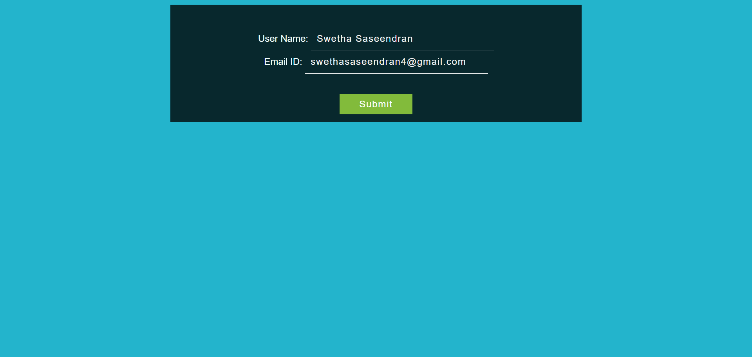

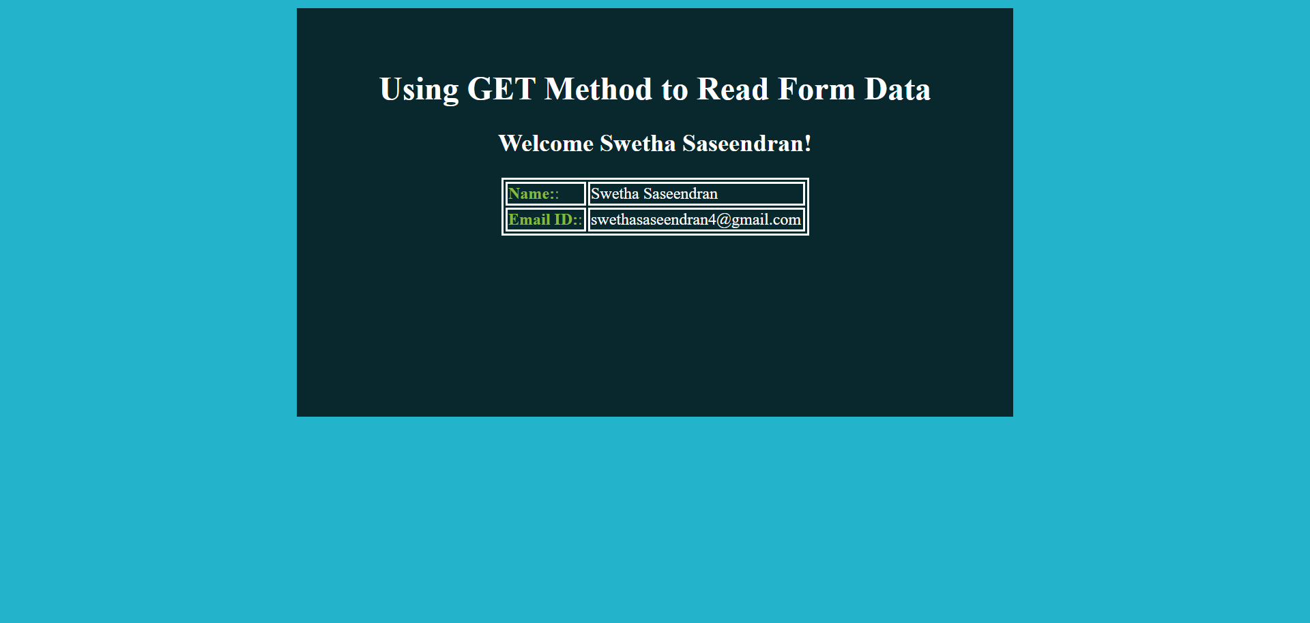

Tomcat Server:

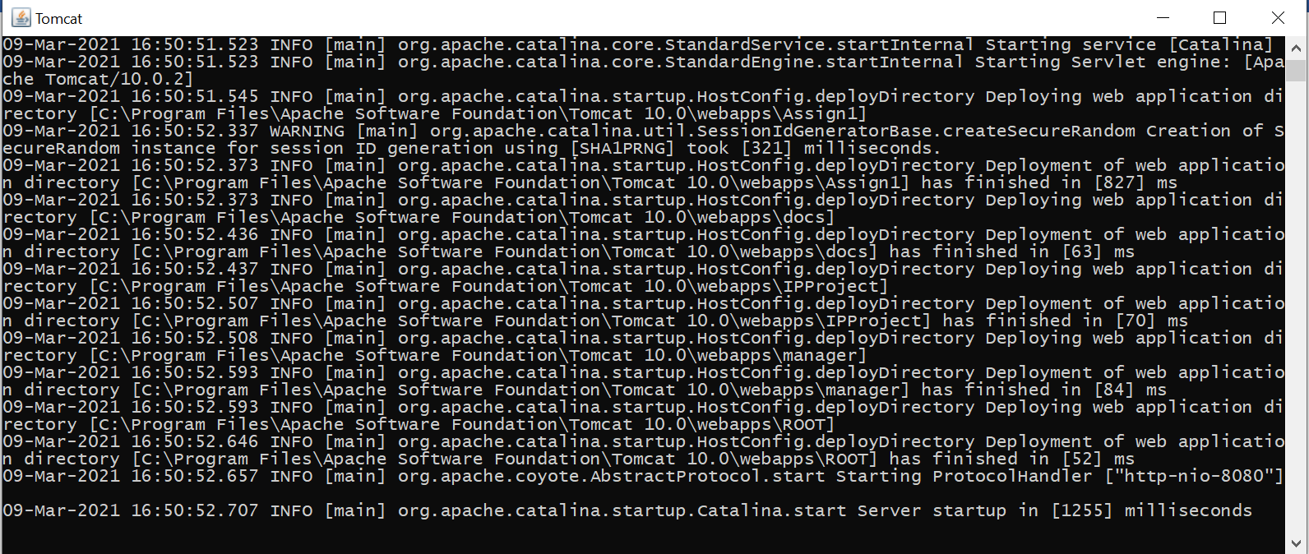

Compilation of Java Code:

